Ideation Phase
Define the Problem Statements
Date
Team ID
Project Name | Automated Network Request Management in ServiceNow
Maximum Marks | 2 Marks
Customer Problem Statement Template:
A problem statement is created to understand the customer's point of view. It helps the team focus on what matters most in order to create an experience people will genuinely value, and to empathise with the customer's real-world challenges before jumping to a solution.
For the Automated Network Request Management in ServiceNow project, two problem statements were defined below — one from the perspective of the person raising a network request, and one from the perspective of the network administrator who must fulfil and document it.
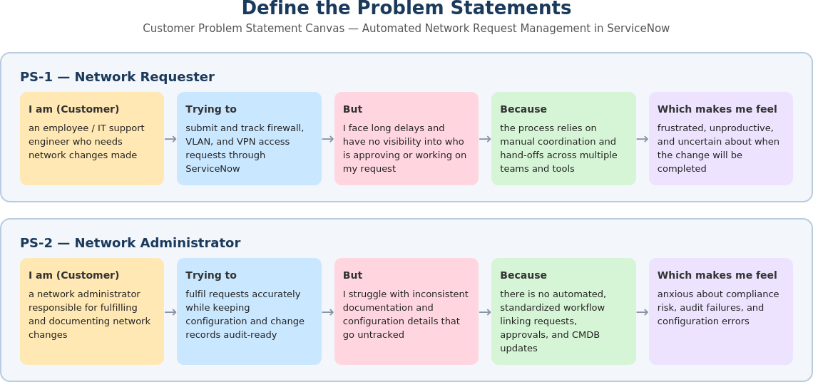
Figure 1: Problem Statement Canvas — Automated Network Request Management in ServiceNow
Problem Statement Table:
Problem Statement (PS) | I am (Customer) | I'm trying to | But | Because | Which makes me feel
PS-1 | an employee / IT support engineer who needs a network change made | submit and track firewall, VLAN, and VPN access requests through ServiceNow | I face long delays and have no visibility into who is approving or working on my request | the process relies on manual coordination and hand-offs across multiple teams and tools | frustrated, unproductive, and uncertain about when the change will be completed
PS-2 | a network administrator responsible for fulfilling and documenting network changes | fulfil requests accurately while keeping configuration and change records audit-ready | I struggle with inconsistent documentation and configuration details that go untracked | there is no automated, standardized workflow linking requests, approvals, and CMDB updates | anxious about compliance risk, audit failures, and configuration errors

